DATABASE CONNECTION

Step 1: Right cllick Database -> Import Data-tier Application
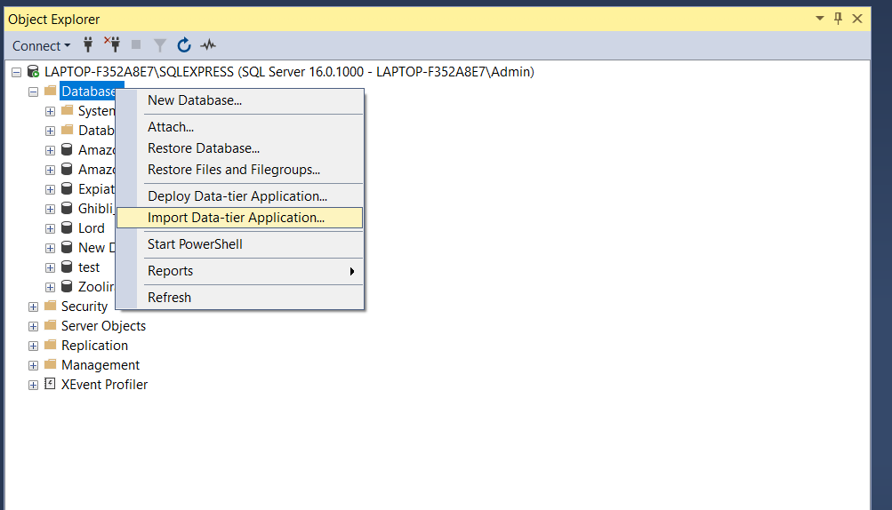
Step 2: Browse to zooDatabase-2025-10-11-11-5.bacpac file
